**MMP 350 CSS Week 2 Class 2**

## Table of Contents

Table of Contents 1

Goals for Week 2 Class 2 1

Goals for the Next Week 1

Review of Final Requirements 1

Review of Mid-Term Requirements 2

How are we going to get there? 2

Review of the 960 grid system 2

Exercise: Screen shots 3

Mac 3

Windows 3

Exercise: Inspecting Elements 3

Review of Tidwell Reading 5

Weekend Homework: Critique a website design relevant to your project 5

To Think About for Next Week: Portfolio Structure 6

## Goals for Week 2 Class 2

1. Review of Midterm requirements
2. Exercises on wire-framing and screen shots
3. Review of Tidwell, more site critiques

## Goals for the Next Week

1. A completed project description
2. A sketch of your proposed site
3. A review of a website related to your proposed project
4. A draft features table to be used in your project

## Review of Final Requirements

Your term project will be a multi-page website. Unless you receive prior authorization from the Instructor, this website will be a portfolio of your work. All projects must have the following features:

1. A WordPress theme created by you, or - with the Instructor’s permission – a customized framework based on technologies such as Angular.js, Bootstrap or Foundation
2. Diverse, representative content. Your site does not have to have extensive content, but it needs representative content. If your site features a slideshow, it must have enough content to demonstrate how the slideshow functions, for example a working next and previous button, and code to handle the start and conclusion of the slideshow. If the slideshow can feature multiple categories of content, you must have a representative sample from each category and a way to switch between categories.
3. A mechanism for handling content. Many sites fail because they are difficult to maintain. If your site is built in WordPress, content management is essentially taken care of. It you are using a framework like Bootstrap, you will be required to document how content gets updated and removed.
4. A coherent visual design that is appropriate for your content.

## Review of Mid-Term Requirements

Your mid-term project is due at 6pm on March 7th. 10% of your grade will be deducted if the project is submitted late, unless prior approval has been received from the Instructor. The project will be a prototype of your term project.

The mid-term project will require the following:

1. A one or two sentence project description. 5 out of 30 marks
2. A design template for a cellphone, laptop, desktop and 4k interfaces. This template can use a drawing tool like Photoshop or Indesign, or a prototyping site like Moqups (moqups.com) 5 out of 30 marks.
3. A features table that compares your project idea with at least one similar web page. A drawing, table or paragraph that explains the context of your idea. If your idea is unique, then you should focus on the latter task. 5 out of 25 marks.
4. A functioning prototype that uses HTML, Foundation and SASS or comparable technologies, such as Bootstrap. 15 out of 30 marks

5 marks for responsive design. Will the design work on multiple platforms? Does its sensibly change content according to platform?

5 marks for stability. How does the design handle different browsers? Does the design handle errors?

5 marks for look and feel. Are too many fonts used? Too many colors? Is there an overriding design idea? Is navigation clear?

### How are we going to get there?

Most of the assignments over the next five weeks will be related to at least one of the mid-term deliverables including:

1. Wireframing and site design (weeks 2 and 3)
2. Site critiques and features tables (weeks 3 and 4)
3. Navigation
4. Color (week 7)
5. Typography (week 6)
6. Styles (ongoing)

*Note that examples will be focused around the creation of a personal portfolio.*

## Review of the 960 grid system

(Based on 960.gs)

The most common grid system is the 960 pixel system

* 12 columns - 60px wide - 20px gutter
* 16 columns - 40px wide - 20px gutter
* 24 columns - 30px wide - 10px gutter

## Exercise: Screen shots

Go to one of the links below, as appropriate for your operating system, and take a screen shot.

### Mac

<http://graphicssoft.about.com/od/screencapturemac/ht/macscreenshot.htm>

### Windows

<http://www.wikihow.com/Take-a-Screenshot-in-Microsoft-Windows>

Or use the Snipping Tool

Note that images included in webpages (at present) should not be more than approximately 100K in size, and ideally around 50k. Use the Image Size tool in Photoshop, or the Image and Scaling tool in GIMP to resize and scale images that you want to post to the Internet.

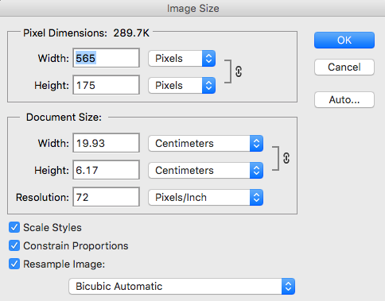

Figure 1: The Image Size dialog box in Photoshop

## Exercise: Inspecting Elements

All major browsers includes tools to allow you to inspect elements on a web page, and to debug Javascript. To get started right click on a screen element you wish to inspect and select Inspect Element. Examine the structure of a page that you find

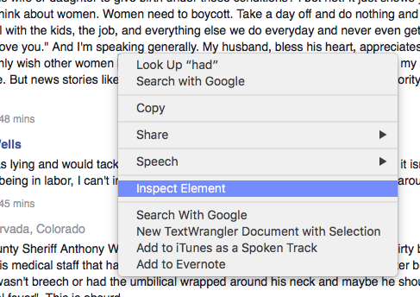

Figure 2: Right click on a screen element to active the Inspect Element tool

The two elements that we are most concerned with this week are the Inspector, which allows you to view the hierarchy of elements on the page (also known as ‘navigating the DOM’) and a tool that lets you view style rules associated with the currently selected element.

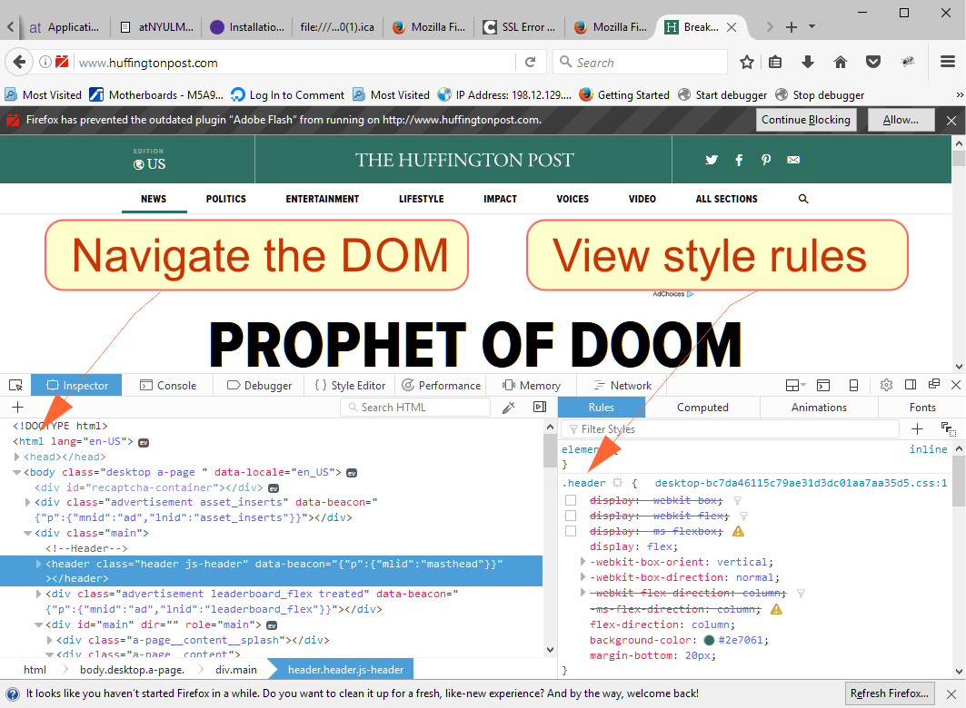

Figure 3: The DOM Inspector and the Rules menu, in Firefox

Click the Console tab to view Javascript and PHP requests (Figure 4).

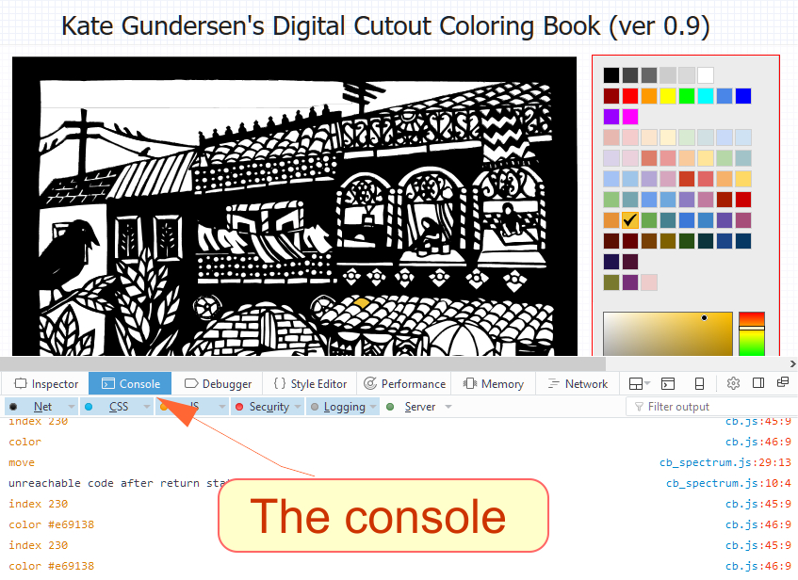

Figure 4: The Console in the FIreFox Inspector

Figure 5 contains a snapshot from Safari:

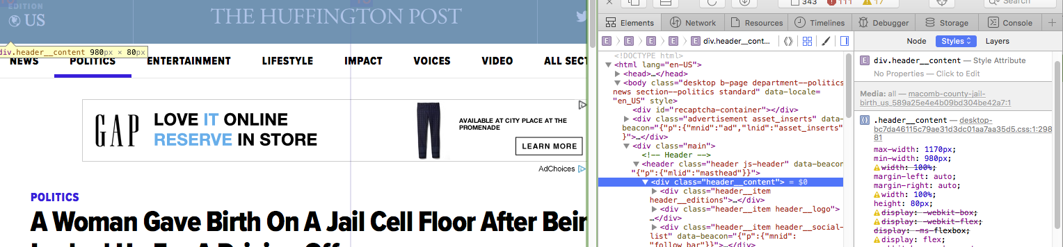

Figure 5: The inspector in Safari. The yellow popup displays width information for the selected element. The right hand panel contains a tool for displaying the DOM and for inspecting the classes associated with the selected element.

## Review of Tidwell Reading

Jennifer Tidwell identifies the follows issues to consider when assessing websites:

* Use of color and fonts
* Use of space
* Use of angles and curves
* Use of texture and rhythm
* Use of multi-media assets
* Use of visual motifs

Class discussion: Using Tidwell’s insights to critque active websites.

## Weekend Homework: Critique a website design relevant to your project

* Choose a website that is relevant to your term project, or that you use often.
* Write short descriptions of 5 design choices that you like
* Write short descriptions of 5 design choices that you don’t like
* Each description should be 1-2 sentences with a screen shot that shows the element discussed
* Email your results to [brianmacmillanteacher@gmail.com](mailto:brianmacmillanteacher@gmail.com) as pdf document. The name of your document should include your name.

## To Think About for Next Week: Portfolio Structure

* Begin organizing the content of your portfolio by thinking about what work you want to show, the categories you will use, and the information you will need, like an About page, Resume, Contact and other pages.
* Begin writing descriptions of you work, including the technology you used and work that was done, and any notes about the creative process or organization that are relevant. Take screenshots of you work and upload them along with the information.
* You will also need a site map. You can make this in a graphics program like Illustrator or Google Draw, or draw something by hand and scan it. Your sitemap should look something like this, with your own content:

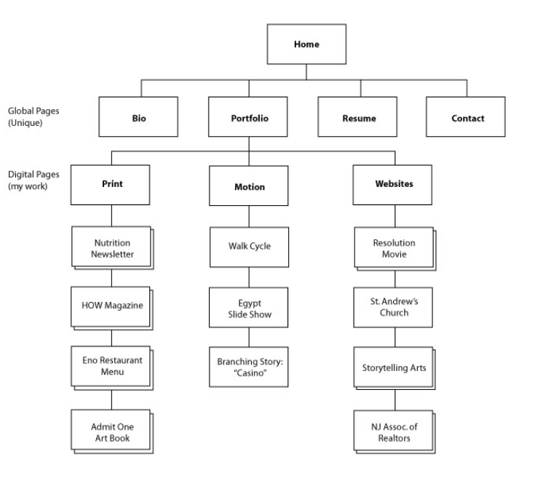

Figure 6: A sample structure for a portfolio website.